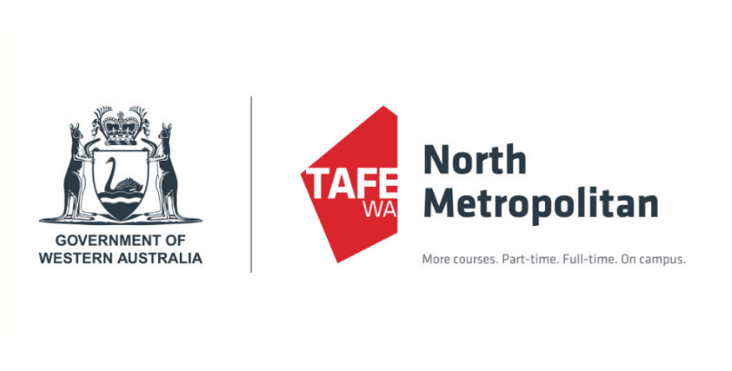


Application Form 2026
CHC43515
Certificate IV in Mental Health Peer Work Scholarship

Please ensure you have read the Information Pack and Frequently Asked Questions before completing this application form.

When answering the questions, please consider the information contained in the Scholarship Application Pack and focus on providing an insight into yourself, what you have learnt and why you would make a good student and a good Peer Worker.

Applications are now open and will close at
5pm, Friday 24th October 2025

In each space, please write as much as you feel best demonstrates your suitability for this scholarship. If you have any queries, including about submitting your application in alternative ways, please contact the CoMHWA Education team on 9258 8911 or education@comhwa.org.au

Contact information and demographics

Please provide us with your contact details:
Full Name: Click here to enter text. | Preferred Name: Click here to enter text.  Pronouns: Click here to enter text.
Address: Click here to enter text.
Phone: Click here to enter text. | Email: Click here to enter text.

Demographic information (please select all that apply to you):
☐ I am a member of the LGBTIQA+ community
☐ I am Aboriginal and/or Torres Strait Islander
☐ I am under 25 years of age
☐ I am over 50 years of age
☐ I am from a culturally and/or linguistically diverse background
☐ I am a person with a physical disability
☐ I am a person with intellectual or learning disability
☐ I am neurodivergent
What is your gender identity? Click or tap here to enter text.

Please select all that apply to you:
☐ I have personal experience of mental and/or emotional distress
☐ I have lived experience of mental and/or emotional distress as a carer or family member
☐ I have personal experience of alcohol or other drug use problems
☐ I have lived experience of alcohol or other drug use problems as a carer or family member
☐ I want to become a Peer Worker
☐ I am a Peer Worker, currently working in a paid capacity
☐ I am a Peer Worker, currently in an unpaid capacity
☐ I have worked as a consumer/carer representative in a paid capacity
☐ I have worked as a consumer/carer representative in an unpaid capacity
Eligibility
- To be eligible for a scholarship you must meet the following criteria (please tick if agreeable):
☐ I have a lived experience of personal mental and/or emotional distress; OR
I have a lived experience of caring for someone with mental and/or emotional distress; OR
I have a lived experience of alcohol and other drug (AOD) experiences in a personal or caring capacity.
☐I can meet the attendance and study requirements to complete the course (discussed on previous page);
☐I am seeking to enter the Peer Workforce, or am currently working in a Peer Workforce role (e.g. mental health, alcohol and other drug, support groups and/or other sectors);
☐I will complete a Language, Literacy and Numeracy test as part of the application process (this will be conducted during the interview process);
☐I have access to the internet, somewhere to suitable to study and stable living circumstances;
☐I have a way to get to campus for classes every week, to Group Peer Co-reflection and to work placement;
☐I am physically well enough to attend classes each week, or can ask for support when needed.
☐I have well developed self-care strategies and access to support networks that I will use to complete the course;
☐I am willing to participate in monthly Group Peer Co-reflection held on campus or online.
☐I am willing to participate in the evaluation of the course and the scholarship program.
* PLEASE NOTE if you are not sure if you meet these criteria it is recommended you contact CoMHWA to clarify. If you do not meet any of these eligibility requirements now it is advisable you wait to apply for the scholarship when you are better placed to meet these requirements.

Skills, interests and experiences

What drew you to this scholarship opportunity and the Cert IV Mental Health Peer Work?
Note: Relate this question to your personal values.
Click here to enter text.

What would you like to share about your lived experience?
Note: Sharing your personal story can be challenging. In this question you do not need to go into great depth, as training will be provided on how to share with safety and intention as part of the bridging course provided by CoMHWA, and throughout the Cert IV course.
Click here to enter text.

What do you think makes you ready to undertake this course of study?
Note: Consider your strengths and ‘recovery mileage’.
Click here to enter text.

What do you feel you have learnt through your journey with personal mental health and/or AOD challenges or caring for someone with mental health and/or AOD challenges, that will assist you in undertaking these studies?
Click here to enter text.
Reflections

Please tell us about any skills, interests, community participation, past study, personal and/or carer experiences (paid or unpaid) that you have had that will support your application.
Note: it’s ok if you don’t have any specific to Peer Work!
Click here to enter text.

Peers can sometimes encounter barriers within the workplace. Please provide your understanding of barriers you consider you have, in completing this course. (e.g. basic computer knowledge, visual impairment, hard of hearing, access to a computer and/or the internet, learning difficulties, memory or attention, negative past experiences, anxiety etc). How would you approach overcoming these barriers? Note: Your honesty in this question shows self-awareness.
Click here to enter text.

Please think of a time when you have supported someone who was going through a challenging situation or period. How did you help them through this time? If you haven’t done this, how do you think you would help them?
Click here to enter text.

At times this course is challenging and requires some resilience. How do you look after your wellbeing in times of stress? What self-care strategies and/or supports do you currently have in place and how would you know it was time to use them?
Click here to enter text.

How would you like to contribute to others and the community as a result of completing the Cert IV Mental Health Peer Work?
Click here to enter text.

Your own readiness to complete this course is vital. How do you see yourself managing the demands of full-time study alongside other areas of your life and what strategies will you put in place to help you?
Note: This relates to managing practical aspects of work/life balance and stability including other considerations such as study time and financial constraints.
Click here to enter text.

Inclusivity and diversity are important for Peer Work, and you may have to work with individuals with diverse experiences and views on recovery that challenge your own. In what way does your background or understanding contribute to these and how would you work through this?
Click here to enter text.
Declaration

☐ I am ready to commit to full-time study for twelve months, including the additional time outside of classes for assignments and role plays.
☐ I am ready to enter the Peer Workforce and/or develop my skills in my current Peer role.

Did you receive help with this application? That’s ok! Providing a short explanation if you received help, will help us to understand what kind of support you might need through the course. Please include information about help received here:
Click here to enter text.

Submit your application
Please return your completed application to CoMHWA by 5pm, Friday 24th October 2025.
Send in Word Document or PDF format to:
- Email: education@comhwa.org.au
- Post: Attn: Maree Jones, 12/275 Belmont Avenue, Cloverdale WA 6105
- In person: 12/275 Belmont Avenue, Cloverdale (Monday – Friday, 9am -5pm)

Please contact Maree Jones if you have questions about submitting your application by an alternative method: 9258 8911 or mjones@comhwa.org.au

