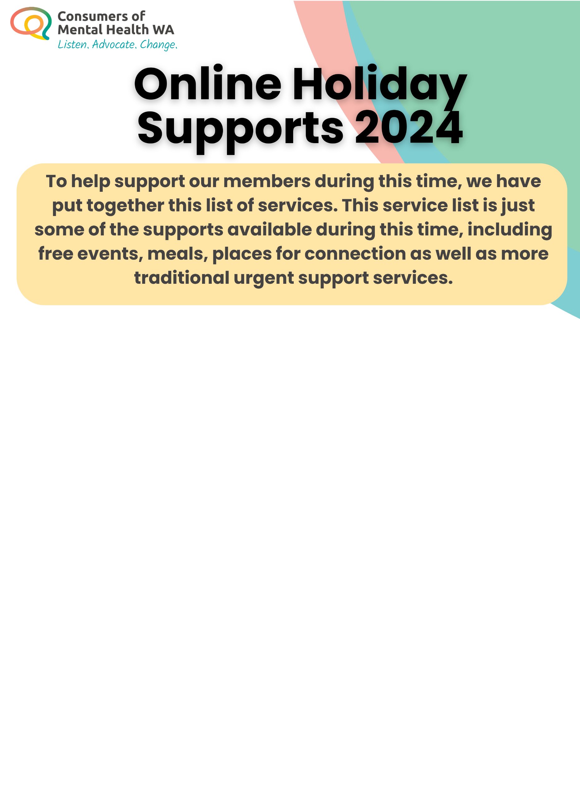

Online Support:
Discharged
- A group for anyone experiencing suicidal thoughts to talk about, vent, sit with, or make sense of suicidal experiences - without fearing hospitalisation or the police being called.
- They also have a group speficially for Trans and Gender Diverse people.
- Online groups are being held throughout the holiday period.
- Click here for more information

Blackfulla Alt2Su
- Online peer support group for Blackfullas to yarn about suicide
- Wednesday 25th December, 3:30pm
- Click here for more information

Sane Forums
- Sane Forums are a supportive moderated community where you can chat with others in similar situations.
- Click here for more information

headspace
- For young people and those supporting them, connect and share with others in a themed group chat or online space.
- Click here for more information

My Circle
- My Circle is the free, private, safe and confidential social platform for 13-25 year olds across Australia. Supported by clinical moderators who are specially trained in youth mental health, My Circle lets you talk to other young people going through challenges just like you.
- Click here for more information

Men’s Anxiety Online Support Group
- Run by Understanding Anxiety, groups are usually comprised of a small number of people who come together to share personal experiences and information in a safe, friendly and supportive environment.
- Click here for more information
Beyond Blue
- Anonymously read, share and learn from people who understand what you're going through. Share your lived experience with our welcoming peer support community at the Beyond Blue Forums. They also have online chat with a counsellor available 24/7.
- Click here for more information

Phone Support:
Peer CARE Companion Warmline
- Peer CARE Companion Warmline is a suicide prevention call-back service providing a safe place for people with a lived experience of suicide to connect with others with a similar lived experience.
- Phone: 1800 77 7337

Mensline Australia
- Available 24/7, MensLine Australia is a free and confidential counselling, information, and referral service for men in Australia with family, relationship, and mental health concerns.
- Phone: 1300 789 978
QLife
- QLife offers phone and online chat support for LGBTIQ+ people and their loved ones wanting to talk about things like sexuality, gender, bodies, feelings, relationships, mental health, and more.
- Phone: 1800 184 527

Griefline
- Griefline provides free and confidential counselling, resources and information to people experiencing grief and loss across Australia.
- Phone:1300 845 745

13YARN
- 13YARN is a free and confidential 24/7 national crisis support line for Aboriginal and Torres Strait Islander people who are feeling overwhelmed or having difficulty coping.
- Phone: 13 92 76

Beyond Blue
- Beyond Blue offers free and confidential 24/7 counselling for anyone looking for a little help with their mental health.
- Phone: 1300 224 636

Family Drug Support
- Family Drug Support is a 24/7 phone support line that provides information, online resources, and counselling for friends and family members of anyone struggling with alcohol and drug misuse.
- Phone: 1300 368 186

Suicide Call Back Service
- Offers free 24/7 counselling via phone, online chat, and video to anyone feeling suicidal, bereaved by suicide or worried about someone else.
- Phone: 1300 659 467.

Blue Knot
- Blue Knot provides short-term counselling and support for anyone affected by complex trauma and helps them to recover and build resilience.
- Phone: 1300 657 380

headspace
- headspace provides mental health and wellbeing support for Australians ages 12-25 as well as for their family and friends.
- Phone: 1800 650 890

Kids Helpline
- Kids Helpline is a free and confidential 24/7 phone and online chat counselling service for kids, teens, young people, and the adults who care about them.
- Phone: 1800 551 800

1800RESPECT
- 1800RESPECT is a free and confidential 24/7 counselling, information, and referral service for anyone in Australia impacted by domestic and family violence.
- Phone: 1800 737 732

National Alcohol & Other Drug Hotline
- The National Alcohol & Other Drug Hotline is a free and confidential 24/7 phone service that provides counselling, advice, and information for those struggling with addiction.
- Phone: 1800 250 015.

SANE
- SANE is a national mental health organisation for people with complex mental health issues and for families and friends that support them. They provide a range of free telehealth and digital services.
- Phone: 1800 187 263

StandBy
- StandBy provides free and confidential phone and face-to-face support for anyone in Australia bereaved or impacted by suicide, regardless of when the loss or experience occurred.
- Phone: 1300 727 247

FriendLine
- FriendLine is for anyone who needs to reconnect or just wants a chat. All conversations with FriendLine are anonymous and our friendly volunteers are ready for a yarn and to share a story or two.
- Phone:

eFriend
- eFriend is a free service that allows people who are feeling low, lonely or isolated to access virtual peer support sessions via video or phone call.

Gambling Help Online
- Gambling Help Online offers free and confidential 24/7 support and online resources for anyone concerned about or affected by gambling.
- Phone: 1800 858 858

Here for You
- Here For You is a statewide confidential, non-judgmental, telephone service for anyone in Western Australia concerned about their own or another person’s mental health issues and/or alcohol and other drug use.
- Phone: 1800 437 348

Butterfly National Helpline
- Free and confidential counselling support for anyone concerned about eating disorders or body image issues, whether you need support for yourself or someone you care about.
- Phone: 1800 334 673

Brother to Brother
- The Brother to Brother crisis line provides phone support for Aboriginal men who need someone to talk to about relationship issues, family violence, parenting, drug and alcohol issues or who are struggling to cope for other reasons.
- The line is staffed by Aboriginal men, including Elders, who have a lived experience in the issues that the line offers support for.
- Phone: 1800 435 799

PANDA
- PANDA (Perinatal Anxiety & Depression Australia) supports the mental health of parents and families during pregnancy and in their first year of parenthood.
- Phone: 1300 726 306

Dollys Dream
- Dollys Dream is a counselling phoneline facilitated by Kids Helpline and anyone can access the support line. Whether you are a young person experiencing bullying or a parent concerned about what your child is going through.
- Phone: 0488 881 033

Hayat Line
- Hayat Line is a free and confidential crisis support line for Muslims in Australia supporting individuals when experiencing a personal crisis or emotional distress.
- Hayat Line provides emotional support for suicide prevention with compassion, connection, rahma, nasihah, and hope.
- Phone: 1300 993 398

Open Arms
- A free, confidential counselling service for Australian veterans, serving personnel, and their families.
- Phone: 1800 011 046

Samaritans WA
- The Samaritans Crisis Line provides 24 hour telephone crisis support for people experiencing distress across Western Australia.
- Phone: (08) 6383 9850
Listening Ear
- Free confidential community support service which provides a safe space to talk through your issues.
- Phone: (02) 9477 6777

Parent and Family Drug Support Line
- Parent and Family Drug Support Line provides 24/7, free and confidential support and information by phone, text message (SMS) and online chat. We help everyone in Western Australia, Australia who may be looking for support with family issues, parenting, substance use, supporting a friend or family member.
- Phone: (08) 9442 5050

Alcohol & Drug Support Line
- Alcohol and Drug Support Line offers 24/7, free, compassionate and confidential support by phone and online chat. We help everyone in Western Australia, Australia who may need emotional support with substance use.
- Phone: (08) 9442 5000

Sexual Assault Resource Centre (SARC) Emergency Line
- Sexual Assault Resource Centre (SARC) Emergency Line provides free and confidential support 24/7 for people over the age of 13 who have experienced a recent sexual assault in the last 2 weeks. Assistance is available for people with a history of sexual trauma between 8:30am - 11pm.
- Phone: 1800 199 888

Support Act Wellbeing Helpline
- The Support Act Wellbeing Helpline is a free phone counselling service for anyone working in Australian music or the creative industries.
- Phone: 1800 959 500.

Support Act First Nations Support Line
- Feeling too shame to yarn with family or friends? If you work in Australian music or the arts, give the First Nations Support Line a call. There’s no judgement and it’s entirely confidential.
- Phone: 1800 959 500 and press option 3.
Thirrili National Indigenous Postvention Service
- Thirrili National Indigenous Postvention Service offers 24/7, free and confidential support and information by phone. We are here for indigenous peoples in Australia who may be struggling or looking for support with grief & loss, self-harm, suicide, supporting a friend or family member, trauma & PTSD.
- Phone: 1800 805 801

National Dementia Helpline
- National Dementia Helpline provides free, compassionate and confidential support over phone and online chat. We are here to help everyone in Australia who may be struggling or looking for support with Dementia & Alzheimer's.
- Phone: 1800 100 500

Rainbow Sexual, Domestic and Family Violence Helpline
- For anyone from the LGBTIQ+ community whose life has been impacted by sexual domestic and/or family violence. Available 24/7
- Phone: 1800 497 212

National Violence and Abuse Trauma Counselling and Recovery Service
- Free, confidential 24/7 trauma specialist counselling.
- Phone: 1800 386 578

TIACS
- TIACS is a FREE mental health counselling service for tradies, truckies, farmers, rural, blue-collar workers and those who care about them.
- Phone: 0488 846 988

MATES Helpline
- An integrated industry intervention and suicide prevention program that promotes good mental health and wellbeing in construction workers.
- MATES helps to prevent suicides amongst construction workers through capacity building and empowering workers to look out for their mates, be more open to talk about mental health and suicide, and to seek help when needed. MATES also runs a 24-hour helpline to support workers at any time of day.
- Phone: 1300 642 111
Youth beyondblue
- Youth beyondblue provides general mental health support for young people aged 12-25 years old.
- Phone: 1300 22 4636

Ngala Parenting Line WA
- Parenting Line offers phone advice and support to parents and carers of children up to 18 years. We listen and respond to parents and the changing needs of families and communities, to meet the challenges of raising children and young people, by offering a range of inclusive, evidence based support services.
- Phone: 1800 111 545

SAMSN Peer Support Line
- Peer Support phone support for all male survivors of child sexual assault.
- Phone: 1800 472 676

Rurallink
- Rural link is an after-hours mental health telephone service for people in rural communities of Western Australia.
- Phone: 1800 552 002

Witness to War
- A national multilingual telephone hotline for people affected by overseas conflicts
- Phone: 1800 845 198

Men’s Domestic Violence Helpline
- The Men’s Domestic Violence Helpline provides telephone information and referrals for men who are concerned about their violent and abusive behaviours and for male victims of family and domestic violence in Western Australia.
- Phone: 1800 000 599

